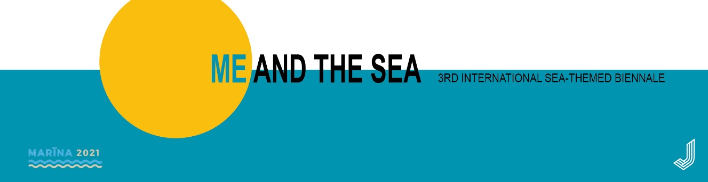

3rd International Sea-themed Biennale "Marīna 2021"
RULES OF PARTICIPATION for the Painting Competition Exhibition

The theme of the Biennale MARĪNA 2021 – Me and the sea – points to the personal relationship each of us has with the sea. Since the ancient times already, the majesty, the destructive force and the mysterious underwater world of the sea has been an inexhaustible source of myths to the peoples living by the sea. According to Latvian myths, God and the Devil created the world, using the sludge from the bottom of the sea. Regardless of the origin of the myths, they indicate the close interaction of people and the sea. Today, both science and art strive to find answers to the following questions: what is the relationship between each of us and nature really like? Is it preserving and future-tended? The union of Me and the sea has a long history and yet – does it also have an infinite and beautiful future?

Organised by: the Jūrmala City Museum and the Jūrmala History and Art Society in co-operation with the Jūrmala City Council
Location, contacts: the Jūrmala City Museum, Tirgoņu iela 29, Jūrmala, LV-2015, e-mail: marina@jurmala.lv
Time of exhibition: 9 July – 29 August 2021. Exhibition opening on 9 July, 16.00
Exhibition participants: individual persons – artists, art students
Medium, number and size of works: a participant can submit no more than 3 two-dimensional works, which can be viewed separately, with the widest side of the painting not exceeding 150 cm. The submitted works have been made during the past two years and correspond to the theme of the exhibition.

Rules of the competition:

The assessment of exhibition works is done in two stages. In the first stage, applications of the submitted works (photographs of works) are assessed by a jury to make a selection of works for the exhibition. In the second stage, works are assessed in the exhibition and prizes are presented.

Application submission to the competition and the assessment of works:

Application submission by 5 April 2021:
- application form available here,
- photographs of works (in 300 DPI resolution, file name – name_surname_titleofwork),
- informal photograph of the author,
- registration fee EUR 20 (an invoice is sent to the applicant after the application has been received).

A written answer about the participation in the exhibition is sent by 13 April 2021. The list of confirmed participants is made available here. If the works are not included in the exhibition, the registration fee is not returned.
The works selected for the exhibition have to be submitted by their author by 10 May 2021, at the Jūrmala City Museum, Tirgoņu iela 29, Jūrmala, LV-2015. In case of sending by mail (postal expenses are paid by the author), the works have to be received in the museum by 10 May 2021.

Assessment and prizes:

- applications and works at the exhibition are assessed by a professional jury;
- the works are assessed in two categories:

1. professional artists – main prize EUR 1,000 EUR (all taxes covered);
2. art students – prize EUR 500 (all taxes covered) and an opportunity to hold a solo exhibition at the Jūrmala City Museum;

- prizes of other organisations/private individuals are awarded at the initiative of the organisers;
- prize winners are announced during the exhibition opening on 9 July 2021;
- every participant of the exhibition receives the catalogue of the exhibition.

Receiving the works after the exhibition:

- the exhibition is dismantled on 30 and 31 August 2021,
- the authors are welcome to receive their works during the two weeks after the dismantling of the exhibition at the Jūrmala City Museum in Jūrmala, Tirgoņu iela 29;
- the works can be sent by mail to the artists to the address they have given (postal expenses are covered by the author).

Rights of organisers:

By submitting the application, the artist agrees that the photographs of works can be used in publications with relation the operation of the Jūrmala City Museum.

